**Name: Jacob Knaup**

**Fall 2018**

**EGR-334**

**Analog - Digital Interface**

**Department of Engineering, Ira A. Fulton Schools of Engineering**

**Take-Home**

**Quiz 2.0 Week 12**

**Tuesday October 30, 2018**

**Due Start of Class Tuesday November 6, 2018**

1. **Given an 12 - Bit ADC with a 5 VDC Input, and a 12 VDC Reference, Please Find Binary Word Output Resulting from the Conversion,**

**[Digital Electronics, Anil K. Maini]**

**[Digital Electronics, William Kleitz]**

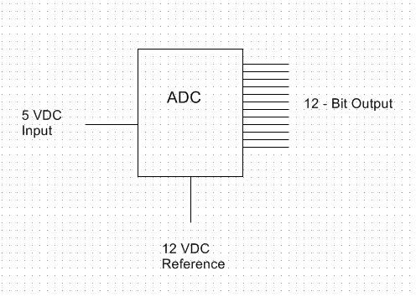

2^12 4096, b = 5/12*499095 = 1706

**12 - Bit Binary Output ____011010101010_____**

1. **Given an 10 - Bit DAC with a 10 VDC Reference, and 204h Input, Please Find Vout**

**[Digital Electronics, Anil K. Maini]**

**[Digital Electronics, William Kleitz]**

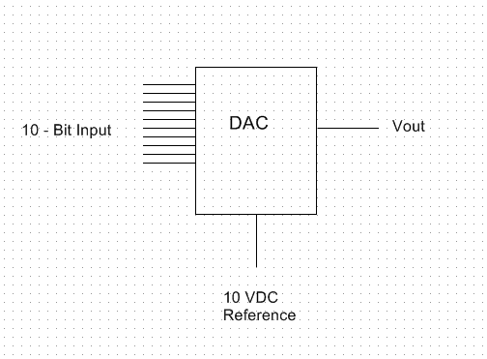

0x204 = 0b1000000100 = 516, 2^10 = 1024

516/1023*10 = 5.04 V

**Vout ___5.04 V___**